**Python Assignment-2**

Q1.What are the two values of the Boolean data type? How do you write them?

**Sol:** A variable of the primitive data type boolean can have two values: **true and false**. Boolean expressions use relational and logical operators. The result of a Boolean expression is either true or false.

Q2. What are the three different types of Boolean operators?

**Sol:** The three types of boolean operators are: **AND, OR, and NOT**

Q3. Make a list of each Boolean operator’s truth tables (i.e. every possible combination of Boolean values for the operator and what it evaluate ).

**Sol:** Truth table for **AND, OR, and NOT**

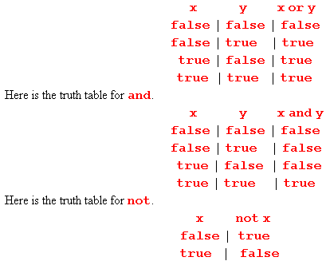

Q4. What are the values of the following expressions?

1. (5 > 4) and (3 == 5)
2. not (5 > 4)
3. (5 > 4) or (3 == 5)
4. not ((5 > 4) or (3 == 5))
5. (True and True) and (True == False)
6. (not False) or (not True)

**Sol:**

1. False
2. False
3. True
4. False
5. False
6. True

Q5. What are the six comparison operators?

**Sol:**  less than (<), greater than (>), less than or equal to (<=), greater than or equal to (>=), equal to (==), and not equal to (!=).

Q6. How do you tell the difference between the equal to and assignment operators? Describe a condition and when you would use one.

**Sol:** The “=” is an assignment operator is used to assign the value on the right to the variable on the left. The '==' operator checks whether the two given operands are equal or not.

* a = 5 #We assign value=5 to ‘a’.
* a == b #when we checks the condition that two operands are equal or not.

Q7. Identify the three blocks in this code:

spam = 0

if spam == 10:

print(eggs)

if spam > 5:

print(bacon)

else:

print(ham)

print(spam)

print(spam)

**Sol:**

a) if spam == 10:

b) if spam > 5:

c) else:

Q8. Write code that prints Hello if 1 is stored in spam, prints Howdy if 2 is stored in spam, and prints

Greetings! if anything else is stored in spam.

**Sol:**

**-----------------------code----------------------------**

spam = int(input("Enter number in spam \n"))

if (spam==1):

print("Hello")

elif (spam==2):

print("Howdy")

else:

print("Greetings!")

Q9. If your programme is stuck in an endless loop, what keys you’ll press?

**Sol:** An infinite loop is a loop that runs indefinitely and it only stops with external intervention or when a break statement is found. We can stop an infinite loop with **CTRL + C** .

Q10. How can you tell the difference between break and continue?

**Sol:** The main difference between both the statements is that when break keyword comes, it terminates the execution of the current loop and passes the control over the next loop or main body, whereas when continue(or jump statement) keyword is encountered, it skips the current iteration and executes the very next iteration in the loop.

Q11. In a for loop, what is the difference between range(10), range(0, 10), and range

(0, 10, 1)?

**Sol:** All three conditions are same as loop iterates from 0 to 9 (10 iterations).

1. range(10) : Here stopping value is 9 (n-1)
2. range(0,10) : starting value is 0 and stopping value is 9
3. range(0,10,1) : starting value is 0 and stopping value is 9 with gap of 1.

Q12. Write a short program that prints the numbers 1 to 10 using a for loop. Then write an equivalent

program that prints the numbers 1 to 10 using a while loop.

**Sol:**

1. **for loop**

for i in range (1,11):

print(i)

1. **while loop**

i=1

while (i<11):

print(i)

i+=1

Q13. If you had a function named bacon() inside a module named spam, how would you call it after importing spam?

**Sol:**  This function can be called with **spam.** **bacon()** (module.function_name)